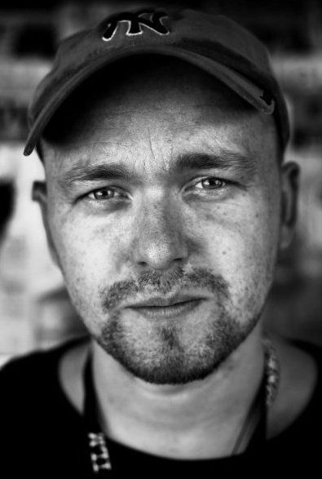
DIRECTOR
Olaf de Fleur
BIO / AWARDS
Olaf de Fleur Johannesson (director, producer) was born in 1975 in Budardalur, a small town in Iceland, and has been a dedicated filmmaker for over a decade. He founded his own independent production company, Poppoli Pictures, in 2003. Poppoli’s first production Shining Star, won him the Best Documentary Feature award at the Icelandic Film Awards in 2004, and he won the award again in 2005 for the feature documentary Africa United. Olaf was selected for the Berlinale Talent Campus in two consequtive years, in 2003 and 2004. Olaf wrote and directed his first feature film The Amazing Truth about Queen Raquela which won him the Teddy award for Best Feature at the Berlinale in 2008.

During post-production on Queen Raquela Olaf shot his second feature film in Iceland in 2007 called Higher Force. The two features both premiered in 2008. Queen Raquela is still traveling the festival circuit and has won numerous awards internationally. The Higher Force premiered internationally at the AFI Film Festival in November 2008. In 2008 Olaf wrote and directed webseries, called Circledrawers, that premiered internationally in May 2009 online worldwide. Currently Olaf and his producer Kristin Andrea have three projects in due for release in 2011, one documentary called Adequate Beings and two fiction features City State and Polite People

DIRECTOR OLAF DE FLEUR - AWARDS:
"Best Documentary" - Icelandic Fiim Awards 2004
"Best Documentary" - Icelandic Fiim Awards 2005
"Best Film" Teddy Awards Berlin Film Festival 2008
"Showtime Vanguard Award" 2008
"Best Film" New York LGBT Film Festival 2008
"Best Film" Cinemanila Grand Jury Prize 2008
"Contribution to cinema language" Exit Festival, Serbia 2008

